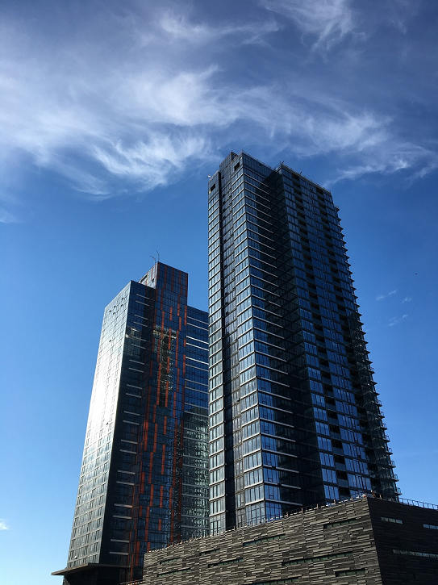
Series 9003
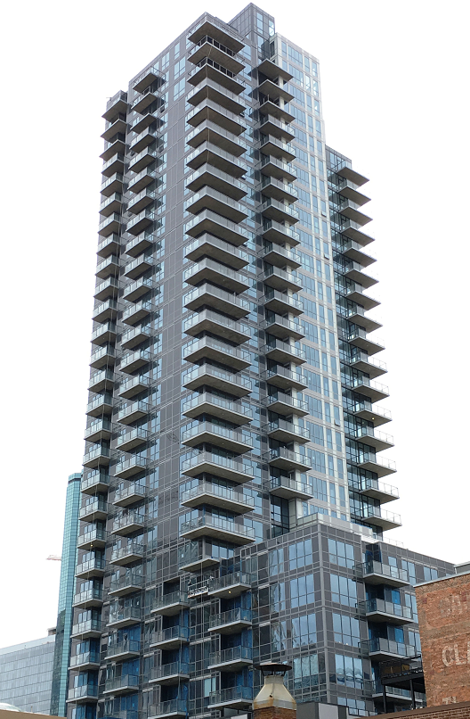
Thermally Broken Aluminum Window Wall Product Specifications
Foreword

This Design Guide provides specifications on the Series 9003 Window Wall with thermally broken aluminum casements, awnings, and fixed windows
This document is intended to provide information on our standard products. Non-standard designs and applications can be reviewed to determine the feasibility on a project-specific basis.
Please email any project specific enquiries to architectural@starlinewindows.com or technical@starlinewindows.com.
This document subject to change without notice.
Starline Windows reserves the right to change or discontinue this product without notice.
www.starlinewindows.com
Document Number TS-00022
© 2021-03-15 Starline Windows

Table of Contents
Product Specification 08 46 13 – Glazed Aluminum Window Wall 5
Part 1 - General 5
1.1 Summary 5
1.2 Quality Assurance 6
1.3 Structural requirements 6
1.4 Test and Performance Requirements 6
1.5 Submittals 8
1.6 Project Conditions 8
Part 2 – Products 9
2.1 Manufacturers 9
2.2 Material 9
2.3 Fabrication 9
2.4 Glazing¹ 10
2.5 Hardware¹ 10
2.6 Finishes (Powder Coating) 11
2.7 Optional Items 12
Part 3 - Execution 14
3.1 Examination 14
3.2 Installation 14
3.3 Field Quality and Control 14
3.4 Protection and Cleaning 14

This page left blank.

Product Specification 08 46 13 – Glazed Aluminum Window Wall
Note: Bolded text in this specification are options that are highlighted for the specifier to select or to list requirements.

Part 1 - General
A high-quality thermally broken 4 ½” aluminum window wall designed for residential high-rise construction.

1.1 Summary
- Section Includes: Glazed Aluminum Window Wall:
- Aluminum Window Wall system shall be Starline’s Series 9003 Window Wall manufactured by Starline Windows with seismic jambs, deflection header, integral slab bypass and casement and/or awning operable vents.
- Work included: Furnish labor, material and other services to complete the fabrication and installation of the windows, including all materials and fitments required for the operation of the units in the manner, direction and performance shown on the shop drawings and specified herein.
Work not included: Structural support of window framing, interior trims. (Specifier list others).
Related work specified elsewhere: (Specifier to list).
- Related Sections: (Specifier to select the following related sections)
- 07 27 00 – Air Barriers
- 07 60 00 – Flashing and Trim
- 07 92 00 – Joint Sealants
- 08 13 16 – Aluminum Doors (Outswing Aluminum Framed Glass Door)
- 08 32 13 – Sliding Aluminum-Framed Glass Door
- 08 44 13 – Glazed Aluminum Curtain Wall
- 08 51 13 – Aluminum Windows
- 08 80 00 – Glazing

1.2 Quality Assurance
- Drawings and specifications for Work of this Section are based upon the Series 9003 Window Wall manufactured by Starline Windows. Whenever alternative products are offered, submit supporting technical literature, samples, drawings and performance data for comparison 10 days prior to closing date. Test reports must be made available on request.
- Windows shall be tested and conform to the AAMA/WDMA/CSA 101 I.S.2/A440-08, AAMA/WDMA/CSA 101 I.S.2/A440-11, and CSA A440SI-09 requirements.
- Manufacturer Qualifications:
- Manufacturer to have a minimum 10 years of documented experience.
- Manufacturer capable of providing an aluminum window system that meet or exceed the performance requirements indicated.
- Manufacturer capable of providing field representation during window installation.
- Installer Qualifications: Installer performing the Work in this Section to have a minimum of 3 years documented experience and approved by the manufacturer.
- Mock-Up: If requested by Consultant, a mock up is to be provided and installed at project site. Mock-up to include acceptable products and manufacturer approved installation methods. Obtain Owner's and Consultant’s acceptance of finish color, and workmanship standard.

1.3 Structural requirements
- Structural performance shall be based on CSA Standard CSA S157-17 “Strength Design in Aluminum”.
- Limit mullion deflection to L/175.
- Allow for deflection of building structure. Aluminum window frames with a head deflection channel and seismic compensation channel shall be designed, fabricated and installed to withstand slab edge vertical differential deflections of maximum 3/4”¹ and seismic inter-story lateral drift movements of elastic +/- 3/4”¹ without significant damage to the fenestration system or in-elastic +/- 2 1/2” ¹ with significant damage expected but framing to be designed to remain anchored to the structure.
¹ Note to specifier: Values may change based on the configuration of the windows. Values to be specified by a Professional Engineer.

1.4 Test and Performance Requirements
Specifier to select from the following performance requirements.
- Fixed window wall shall meet performance class CW-PG50¹ when tested to AAMA/WDMA/CSA 101 I.S.2/A440-08, AAMA/WDMA/CSA 101 I.S.2/A440-11, and CSA A440SI-09:
- Air Infiltration: Fixed window air infiltration shall not exceed 0.01 cfm/ft² (A3) when tested in accordance with ASTM E 283 with a pressure difference of 6.24 psf / 300 Pa.
- Water Penetration Resistance:
- There shall be no water infiltration for fixed windows when tested in accordance with ASTM E547 with a pressure difference of 15.04 psf / 720 Pa (Laboratory Test).
- There shall be no water infiltration for fixed windows when tested in accordance with AAMA 502-08 with a pressure difference up to a maximum of 10.4 psf / 500 Pa (Field Test) ²
- Uniform Load Deflection Test: The deflection of fixed window shall not exceed L/175 and there shall be no permanent set when tested in accordance with ASTM E330 with a design pressure of 50 psf / 2400 Pa, positive and negative.
- Uniform Load Structural Test: There shall be no damage to hardware, accessories, fasteners, or any other damage that would render the window in operable when tested in accordance with ASTM E330 with a structural test pressure of 75.19 psf / 3600 Pa, positive and negative.
- Forced Entry Resistance: Fixed window shall meet grade 20 when tested to ASTM F588.
- Thermal Performance³
      - U-value: The maximum fixed window thermal transmittance U-value shall be 0.25 BTU/ hr*ft²*°F (1.43 W/m²*k) when tested in accordance with AAMA 1503.1 and CAN/CSA-A440.2. Windows shall be tested and labeled to N.F.R.C. standard 100 & 200.
      - Solar Heat Gain Coefficient: A (maximum or minimum) of 0.30.
      - Visible Light Transmittance: A (maximum or minimum) of 0.53.
- Operable windows (ventilator) shall meet performance class CW-PG50¹ when tested to AAMA/WDMA/CSA 101 I.S.2/A440-08, AAMA/WDMA/CSA 101 I.S.2/A440-11, and CSA A440SI-09:
- Air Infiltration: Operable window air infiltration shall not exceed 0.01 cfm/ft² (A3) when tested in accordance with ASTM E 283 with a pressure difference of 6.24 psf / 300 Pa.
- Water Penetration Resistance:
- There shall be no water infiltration for operable windows when tested in accordance with ASTM E547 with a pressure difference of 15.04 psf / 720 Pa (Laboratory Test).
- There shall be no water infiltration for fixed windows when tested in accordance with AAMA 502-08 with a pressure difference up to a maximum of 10.4 psf / 500 Pa (Field Test)²
- Uniform Load Deflection Test: The deflection of operable window shall not exceed L/175 and there shall be no permanent set when tested in accordance with ASTM E330 with a design pressure of 50 psf / 2400 Pa, positive and negative.
- Uniform Load Structural Test: There shall be no damage to hardware, accessories, fasteners, or any other damage that would render the window inoperable when tested in accordance with ASTM E330 with a structural test pressure of 75.19 psf / 3600 Pa, positive and negative.
- Forced Entry Resistance: Operable window shall meet grade 20 when tested to ASTM F588.
- Operable windows shall meet performance criteria for Operating Force and Force to latch when tested to ASTM E2068.
- Thermal Performance³
- U-value:
  - Awning: The maximum awning window thermal transmittance U-value shall be 0.37 BTU/ hr*ft2*°F (2.12 W/m²*k) when tested in accordance with AAMA 1503.1 and CAN/CSA-A440.2. Windows shall be tested and labeled to N.F.R.C. standard 100 & 200.
  - Casement: The maximum casement window thermal transmittance U-value shall be 0.38 BTU/ hr*ft2*°F (2.16 W/m²*k) when tested in accordance with AAMA 1503.1 and CAN/CSA-A440.2.Windows shall be tested and labeled to N.F.R.C. standard 100 & 200.
- Solar Heat Gain Coefficient:
  - Awning: A maximum or minimum of 0.25.
  - Casement: A maximum or minimum of 0.25.
- Visible Light Transmittance:
  - Awning: A maximum or minimum of 0.42.
  - Casement: A maximum or minimum of 0.42.
¹ Note to specifier: Performance class result is based on lab testing and will vary by configuration and glass type. Contact Starline Windows for information on how the product can be engineered to achieve higher performance class than specified above.
² Note to specifier: 500Pa / 10.4 psf is the maximum field test result that can be achieved. Should the Project Specifications state a water penetration resistance field test pressure of a lesser value, the project specified values shall govern. The water penetration resistance field tests follow the criteria and testing procedures as outlined in the AAMA 502-21 specification standard.
³ Note to specifier: Thermal performance depends on glass specified. For triple glazed values the above test was preformed using 46mm triple glazed insulated glass unit (6mm/Argon/4mm/Argon/4mm) with Standard high-performance soft coat (sputtered) Low E which is applied to surface #2, 90% argon + 10% air fill, with warm edge spacer bar. Please note: A second low E coating can be applied to surface #4 to further increase the thermal performance. A third low E coating can also be applied to surface #6, to further increase the thermal performance. The NFRC test sizes were 79” x 79” (2000mm x 2000mm) for a fixed window wall, 24” x 59” (600mm x 1500mm) for a casement window and 59” x 24” (1500mm x 600mm) for an awning window.

1.5 Submittals
- Product Data: Submit complete product data on system being used.
- Shop Drawings: Submit complete shop drawings which include floor plans, elevations, window schedule, and product components including anchorage, fasteners, accessories and finish colour.
- Samples: Submit glass and frame colour(s) samples.
- Close-out Submittals:
- Warranty: Submit executed Manufacturer’s warranty which provides a guarantee for the complete installation provided under this section against defective material and workmanship which appears within a period of two years from the date of substantial completion.
- Project Record Documents: Submit operation and maintenance data for installed product in accordance with General Conditions

1.6 Project Conditions
- Field Measurements: Verify actual measurements / openings by field measurements prior to fabrication, until it is agreed upon in writing between the Window Manufacturer and the General Contractor that floors become “typical”. Once typical the windows can be ordered off the previous field measurements.
- Indicate field measurements on shop drawings.

Part 2 – Products

2.1 Manufacturers
- Acceptable Manufacturers: Starline Windows
- Glazed Aluminum Window Wall: Series 9003
- Substitutions: Approved alternates

2.2 Material
- Aluminum Extrusion: 4 1/2" deep perimeter frame member. Frame member and intermediate bars are extruded from aluminum sections of 6063 alloy, T5 temper with a minimum thickness of 0.064”.
- Fasteners: Stainless steel and of sufficient size and quantity to perform their intended function.
- Glazing Gaskets: Extruded Santoprene.
- Exterior Glazing Tape: Tremco Polyshim II
- Heel Bead: DOWSIL 1199
- Glass Setting Blocks & Edge Blocks: FPVC, Neoprene, EPDM, Santoprene or silicone with an 80 to 90 ± Shore A durometer hardness. Block material shall be compatible with sealed unit edge sealant. Setting blocks for sealed units with silicone edge seals must be silicone.
- Glazing bead: Extruded PVC and glazed from the interior.
- Thermal break: Polyamide.

2.3 Fabrication
- Fabricate framing from extrusions of size and shape shown on shop drawings.
- Interior and exterior extruded aluminum framing sections shall be integrated with a Polyamide thermal break to form a rigid composite assembly without the use of fasteners or other thermal bridging elements. Dry shrinkage of polyamide thermal break shall not exceed 0.10% of the framing member length.
- Main framing extrusions shall be butt-corner construction.
- Operable sash (ventilator) extrusions shall be mitre-corner construction.
- All framing profiles shall be straight and free of deformations and defects.
- Joints shall be accurately machined, fitted and sealed.
- Coupling mullions shall be designed to provide a functional split to permit modular construction and allow for thermal expansion.
- Perimeter frame shall be 4 1/2” deep with a minimum wall thickness of .064" (1.60mm) and be thermally broken.
- Operable window (ventilator) shall be 3 1/2" deep with a minimum wall thickness of .064" (1.60mm) and be thermally broken.
- All frame corners are mechanically joined by stainless steel screws.
- All interior joints and interior screw heads shall be sealed with a non-hardening sealant.
- Operable sash (ventilator) shall be double weather stripped with black santoprene bulb seal weather-stripping for the full perimeter at the interior and exterior of the ventilator.
- All glazing pockets shall be vented, pressure equalized, and drained to the outside.
- Glass bead shall be PVC and a snap-in screwless type.
- Silicone heel bead shall be applied at perimeter of insulated glass units.

2.4 Glazing¹
- Triple glazed, double seal insulated glass unit with an overall thickness of 1 3/4” (46 mm). Double glazed available (See 2.7.A.1 of this specification).
- Standard high-performance soft coat (sputtered) Low E applied to surface #2.
- Black warm edge spacer with argon fill.
- Minimum glass thickness shall be 4mm. Glass thickness and quality shall conform to the requirements of the U.S.A. and Canadian Code for commercial construction, current edition.
- Where practical, glazing shall be installed at the factory before shipping to site.
¹ Note to specifier: Glazing noted above is based on Starline Windows standard product offering. There are various other options available. See 2.7.A. of this specification.

2.5 Hardware¹
- Hardware for the aluminum operable sash (ventilator) and window frames shall be furnished by the window manufacturer.
- Where practical, all hardware fittings shall be installed at the factory before shipping to site.
- Hardware shall be as follows:
- Push out Operable sash (ventilator) shall be hung on concealed heavy-duty stainless steel four bar friction hinges with adjustable friction shoe. Hinges are completely concealed when operable sash (ventilator) is in its closed position.
- Zinc-alloy cam handle shall lock positively against the mounted keeper. Handles are available in black, white and silver.
- Mounted keeper is PVC and is available in black, white and silver.
- 60° hinge restricted to 4”.
¹ Note to specifier: Hardware noted above is based on Starline Windows standard product offering. There are various other options available. Refer to 2.7.J of this specification.

2.6 Finishes (Powder Coating)
- All exposed surfaces of aluminum door and framing members shall be free of scratches and other serious surface blemishes.
- Finishes¹.
- Thermoset coating specifically designed for architectural systems. Coating to comply with AAMA 2603 specification and / or
- Upgrade to a thermoset super durable coating which complies with the AAMA 2604 specification standards. The AAMA 2604 standard demands advanced levels of weather resistance, gloss and colour retention, and corrosion resistance, among other increased standards when compared to the AAMA 2603 specification standard.
- Upgrade to a thermoset fluorocarbon coating which is a superior coating that complies with the AAMA 2605 specification standard. The AAMA 2605 standard demands advanced levels of weather resistance, gloss and colour retention, and corrosion resistance, among other increased standards when compared to the AAMA 2603 and AAMA 2604 specification standards.
- Colour Options².
- Standard colours are as follows. (Specifier to select from the standard colour(s) listed below). These standard colours are available in the AAMA 2603, AAMA 2604 and AAMA 2605 specification.
White  Charcoal Grey | Black | Brown | Silver³
- Semi-standard colours⁴ are as follows. (Specifier to select from the semi-standard colour(s) listed below). These semi-standard colours are available in the AAMA 2603, AAMA 2604 and AAMA 2605 specification.
Graphite Grey  Black Charcoal | Grey Velvet  Kendall Charcoal | Iron Mountain Grey  Beige | Metal Shavings Grey

¹ Note to Specifier: Select 2.6.B.1 and/or 2.6.B.2 and/or 2.6.B.3. Option to have dual frame colour and / or AAMA 2603 coating on interior and AAMA 2604 or AAMA 2605 coating on exterior is available, if standard and / or semi-standard and / or custom colour is selected. Refer to 2.7.I.1 of this specification. AAMA 2604 or AAMA 2605 specification standard on exterior of frames may be required in some building codes, bylaws, jurisdictions, etc.
² Note to Specifier: Refer to 2.7.I.2 of this specification for Custom Colours.
³ Note to Specifier: Silver is available for an additional cost.
⁴ Note to Specifier: Semi-standard colours are available for an additional cost. May require up to a 4-week lead time.

2.7 Optional Items
(Specifier to select from the following options)
- Glazing
- Double glazed (Series 9000 Window Wall)
- Varying glass thickness available in 4mm and greater(Specifier to select glass thickness required).
- Tinted, obscured & reflective glass
- Spandrel glass
- Laminated glass
- Sandwich panels
- Coupling mullions – Wide range of couplers are available (all thermally broken) to suite a variety of configurations i.e.: 90°, 135°, 180°, etc.
- Bypass¹
- Spandrel glass on exterior / Aluminum or galvanized panel on interior.
- ~R3 insulation at slab edge (DC6 Standard Detail)
- ~R6 insulation at slab edge (DC7 Upgraded Detail)
- In-slab Ducts
- Flush metal panel on the exterior / Aluminum or galvanized panel on interior.
- ~R3 insulation at slab edge (DC6 Standard Detail)
- ~R6 insulation at slab edge (DC7 Upgraded Detail)
- In-slab ducts
- Top hat metal panel on exterior / Aluminum or galvanized panel on interior.
- ~R3 insulation at slab edge (DC6 Standard Detail)
- ~R6 insulation at slab edge (DC7 Upgraded Detail)
- In-slab ducts
- 1, 2”, and/or raised metal panel on exterior / Aluminum or galvanized panel on interior.
- ~R2 insulation at slab edge (DC6 Standard Detail)
- ~R6 insulation at slab edge (DC7 Upgraded Detail)
- In-slab ducts *Not available for 1” raised metal panel.
- Spandrel glass IGU on exterior / Aluminum or galvanized panel on interior.
- Opaque areas other than Bypass¹
  - Spandrel glass on exterior / Aluminum or galvanized panel on interior.
  - Flush metal panel on the exterior / Aluminum or galvanized panel on interior.
  - Top Hat metal panel on exterior / Aluminum or galvanized panel on interior.
  - 1”, 2”, and/or 4” raised metal panel on the exterior / Aluminum or galvanized panel on interior.
  - Spandrel glass IGU on exterior / Aluminum or galvanized panel on interior.
- Transom Ducts
- Climb deterrent for fixed window only.
- Stage anchor
- Finishes (Powder Coating)
  - Dual frame color – 1 color on exterior and 1 color on interior (refer to 2.6.C for color options)
  - Finish to comply with AAMA 2603 standard on both interior and exterior.
  - Finish to comply with AAMA 2604 standard on both interior and exterior.
  - Finish to comply with AAMA 2605 standard on both interior and exterior.
  - Finishes to comply with AAMA 2603 standard on interior and AAMA 2604 standard on exterior.
  - Finishes to comply with AAMA 2603 standard on interior and AAMA 2605 standard on exterior.
  - Custom colours². Virtually any colour can be matched or very closely matched. The scope of work and overall custom colour quantity will be reviewed by Starline on a project-specific basis to determine the feasibility of the custom colour request.
- Hardware:
  - Multi point locking hardware. The multi point handle is available in black, white, and silver. The multi points, not visible when window is in closed position, are available in black and white only. When multipoint locks are selected, the minimum vent height for a casement is 22” but shall not exceed 60” in height. The minimum vent width is for an awning is 22” but shall not exceed 48” in width.
  - Restrictor: Custodial
  - 90° egress hinge.
- Extruded aluminum glazing bead (powder coated to match interior window color).

¹ Note to Specifier: At the concrete bypass itself, there is no interior aluminum or galvanized panel.
² Note to Specifier: Custom colours are available for an additional cost premium. An approximate 12-week lead time is required to procure custom colour requests.

Part 3 - Execution

3.1 Examination
- Installer to examine openings, structural support, substrates and any other conditions that would affect the installation, for compliance with manufacturer’s instructions.
- Verify rough opening dimensions.
- Verify sill is within tolerance of levelness to ensure adequate shimming to obtain proper drainage.

3.2 Installation
- Install manufacturer’s system in accordance with manufacturer’s approved shop drawings.
- Windows shall be installed and adjusted by experienced personnel in accordance with the manufacturer instructions and approved shop drawings.
- All items in this section shall be set in their correct location and shall be set level, square, plumb and at proper elevations and in alignment with other work.
- The windows are installed at site with a maximum variance to plumb of +/- 0.25%. (+/- 1/4" / 96”).

3.3 Field Quality and Control
- Manufacturer’s Field Services: Upon Owner and/or Consultants written request, provide manufacturer’s field service representative for site visit to inspect installation and to ensure accordance with manufacturer’s instruction and approved shop drawings.
- Field Tests: Owner and/or Consultant may choose to conduct tests for water penetration and air infiltration.
  - Testing Standard per AAMA 502.
  - Field testing shall be performed by a qualified independent testing agency.
  - Field testing should not occur until the window has been installed and the caulking is cured. Ensure the products used to complete building envelope tie in (membrane, caulking, flashing, cladding, etc.) are installed complete and have cured.

3.4 Protection and Cleaning
- Protection:
- Windows shall be protected with blue poly during and after installation until acceptance by the General Contractor. Thereafter, it shall be the responsibility of the General Contractor to protect the installed product from construction damage.
- Windows shall be isolated from concrete, mortar, plaster and dissimilar metals with bituminous paint or other isolation coatings.
- Cleaning: It shall be the responsibility of the General Contractor to maintain protection and provide final cleaning.

Note: This specification is intended to be used by a qualified Specifier and will require modifications for the project specific requirements. This specification is not intended to be use verbatim as the project specific specification.
Laws, building and safety codes governing the design and use of this product vary widely. Starline Windows does not control the selection and use of this product and assumes no responsibility therefor.

